ỦY BAN NHÂN DÂN THÀNH PHỐ HỒ CHÍ MINH
TRƯỜNG CAO ĐẲNG LÝ TỰ TRỌNG THÀNH PHỐ HỒ CHÍ MINH

BÀI GIẢNG CHI TIẾT

Môn học: NÓI
Lớp : 18T4-NNA1,3 Khoá : 2018
Họ và tên giảng viên : PHẠM THỊ THU HIỀN
Năm học: 2019 - 2020

UNIT 1: NEW FRIENDS
PART 1: HOW ARE YOU
1.1 Vocabulary
-Write first name, middle name and last name in the chart on the board for example.
-Do the pair work activity asking for and giving name with the partner.
1.2 Conversation
-Play the audio and ask Student to answer the questions:
What is Steve's last name? What's Emma's middle name?
Answer keys:
Hill
Lori
-Practice the conversation.
1.3 Language Booster
-Notice the different ways we greet people and say goodbye
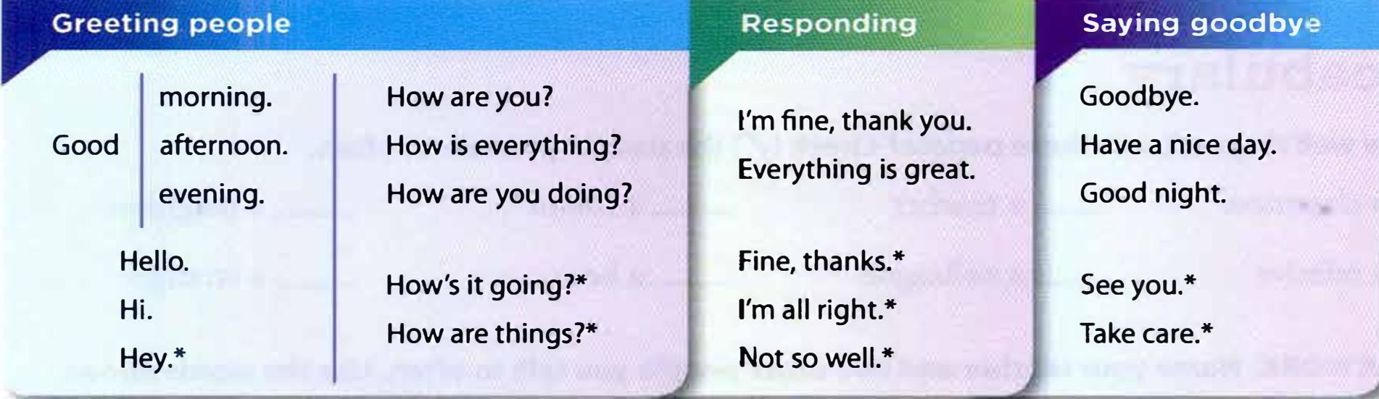
-Do the pairwork activity: Take turns greeting each other and saying goodbye.
-The answer will vary and give feedback.
1.4 Listening
-Play the audio and ask Student to circle the correct answer.
- Listen again. Write the expression each person uses to say goodbye
Answer keys:
CD1. A 1. informal
2. formal
3. informal
4. formal
B. 1. See you later
2. Good night
3. Bye
4. Good bye
1.5 Speak with confidence
-Go around the class. Greet your teacher and classmates, say your name, and then say goodbye.
PART 2: NICE TO MEET YOU
2.1 Vocabulary
-Explain new vocabulary: classmate, teacher, friend, neighbor, relative, colleague, boss, stranger.
-Do the pair work activity: Name your teacher and two other people you talk to often using the words above.
-Give feedback for students.
2.2 Conversation
-Do the listening activity and answer the questions:
Where does Jesse live? How old is Tizy?
Answer key:
apartment 19, four month old.
- Do the pair work activity: Practice the conversation.
-Give feedback.
2.3 Language Booster
- Notice the diﬀerent ways we introduce ourselves and other people.

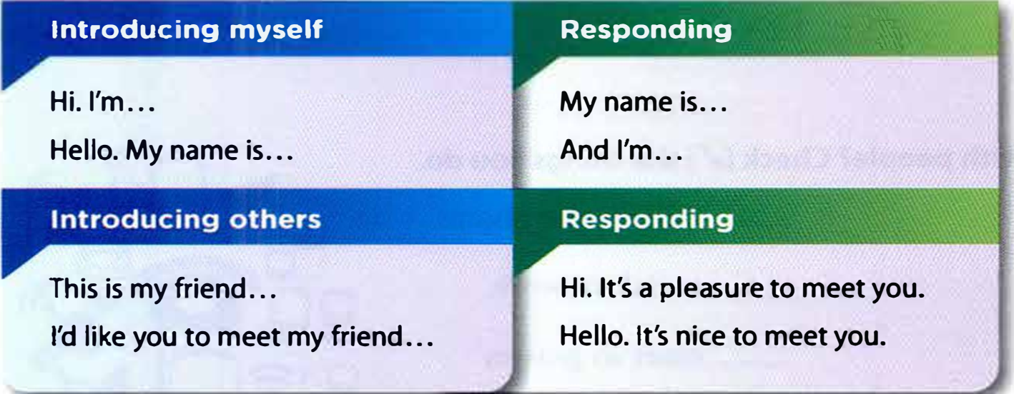
-Do the group work activity: Introduce yourself, then introduce the person next to you.
-Give feedback on Student’s presentation.
2.4 Pronunciation
- Reduction of to
-Play the audio and ask Students to notice how “to” is reduced in these sentences.
Nice to meet you.
I'd like you to meet my classmate.
It's great to meet you.
-Do the pair work activity: Take turns practicing the sentences above.
-Give feedback on Student’s presentation.
2.5 Speak with confidence
-Answer these questions with partners:
What's your first name?
What's your last name?
Where are you from?
Where do you work/study?
-Do the class activity: Go around the class. Introduce your partner to others.
-Give feedback on Student’s presentation.
PART 3 CAN YOU SAY THAT AGAIN
3.1 Vocabulary
-Introduce some ways to communicate with people: write a letter, social network, instant message, meet in person, send a text, video chat.
-Tell your partner how you communicate with your friends.
-The answer will vary.
3.2 Coversation
-Listen the audio and answer the questions:
What does Matt need help with?
What is Joe's e-mail?
Answer keys:
-Matt needs help with his homework.
-j-o-e@n-e-w-mail.com
-Do the pairwork activity: Practice the conversation.
3.3 Language Booster
-Notice the diﬀerent ways we ask for personal information and ask for repetition.

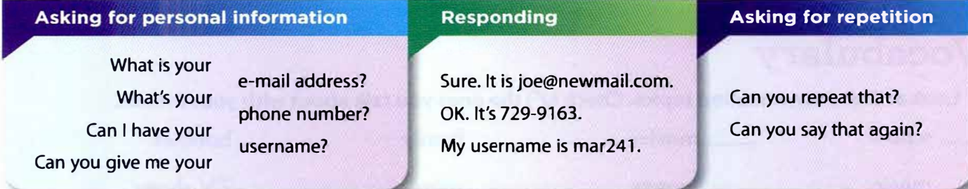
-Do pair work activity: Take turns asking for personal information and ask for repetition.
-Give feedback on Students’presentation.
3.4 Listening
-Listen two friends are sharing information.
-Answer the question:
How many times do they ask for repetition?
Answer keys:
a. Delia: 2 times
b. Andy: 1 time
-Listen again and complete the chart.

Answer keys:
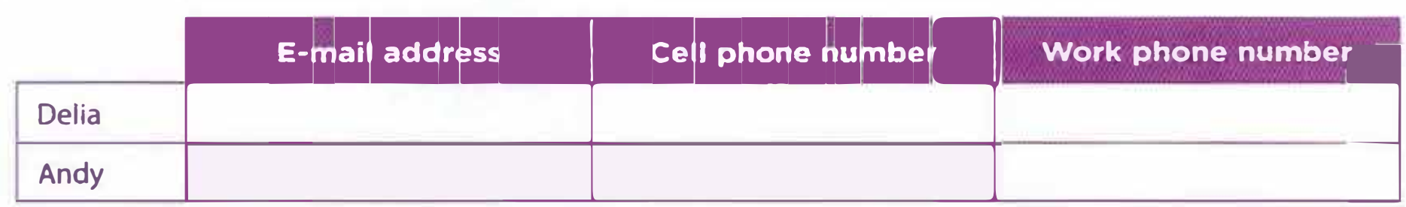
Delia: delial5@snmail.com, 968-8815, 752-9947
Andy: andy@245mail.com, 361-0018, 902-9914
3.5 Speak with confidence
-Go around the class and make a list by asking fve people for their names, phone numbers, and e-mail addresses. Ask for repetition as needed.
-The answer will vary.
-Give feedback on Students’presentation
PART 4 NICE WEATHER, ISN’T IT
4.1 Vocabulary
-Ask Students to look at these conversation topics: school, movies, family, hobbies, music, money, sport, TV shows and check the ones they talk about with their friends.
4.2 Conversation
-Listen and answer the questions:
What do Chris and Maria talk about?
Does Maria like the song?
Answer keys:
-weather, school, music.
-Maria doesn’t like the song.
-Practice the conversation and present in class.
-Give feedback.
4.3 Language Booster
-Notice the different ways we make small talk.

-Practice making small talk and responding. Use the pairs of words below.
sunny/cloudy
beautiful/terrible
school/work
hot/cold
-Give feedback on Students’presentation.
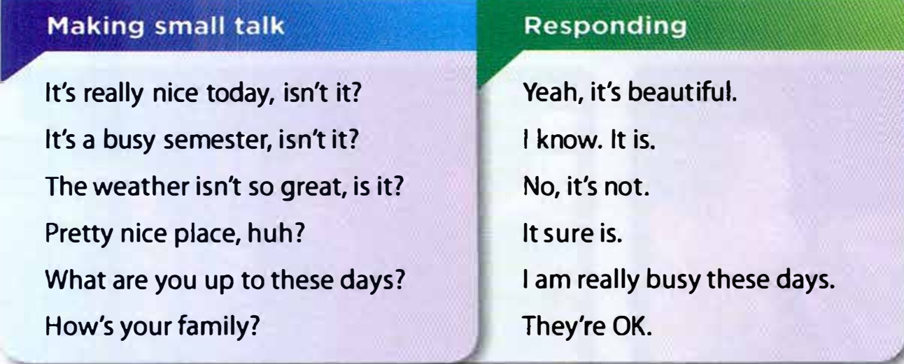
4.4 Pronunciation
-Listen and notice how the intonation falls in tag questions when you expect the listener to agree.
-Practice these sentences:

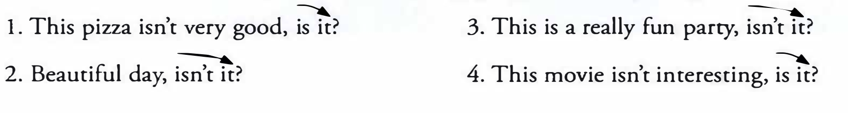

4.5 Speak with confidence
-Imagine the situation: You are at a class party. Walk around and greet six diﬀerent people.
Use the small talk expressions or think of your own.
-Invite some groups to present in class.
-Give feedback.

UNIT 2: INTERESTS
PART 1: I LOVE HIP HOP!
1.1 Vocabulary
-Explain the new vocabulary: opera, blues, pop, folk, country, vocal, techno, heavy music, classical, reggae.
-Ask Students what kind of music they like.
-Do the pair work activity: Tell your partner what kind of music you listen to.
1.2 Conversation
-Listen and answer questions:
Does Peter like opera ? What kind of music do Peter and Sandra like?
Answer keys:
Yes, he does.
Peter likes heavy music and vocal.
Sarah likes classical and vocal.
-Practice the conversation with the partners.
-Peer-correction.
1.3 Language Booster
-Notice the diﬀerent ways we talk about likes and dislikes.
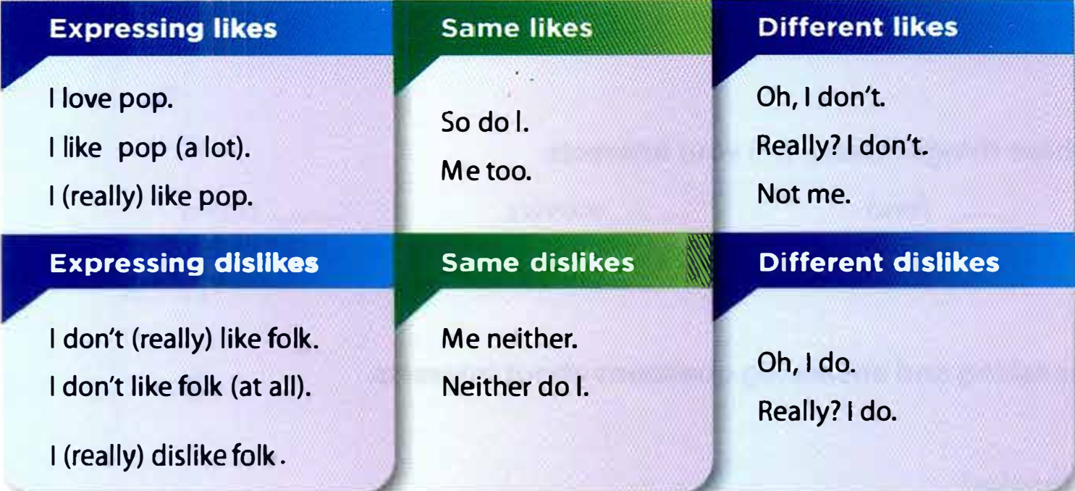

-Do the pair work activity:Take turns expressing likes and dislikes. Use the words from the Vocabulary section.
-Invite some pairs to speak up and give feedback.
1.4 Listening
-Listen exercise A: number the kinds of music you hear from 1 to 5 in the order you hear them.
-Listen exercise B: Two friends are listening to music on the radio. Write S (they like the same kind of music) or D (they like diﬀerent music)
Answer keys:
Exercise A: 1. clip of classical music 2. clip of folk music 3. clip of blues music 4. clip of country music 5. clip of pop music
Exercise B: S. a S. b D. c D. d S. e
1.5 Speak with confidence
-Complete these sentences with your own opinion.
1. I like _________ a lot.
(a kind of music)
2. I don't like---------- very much.
(a kind of music)
3. I really like--------- a lot.
(a singer)
4. I don't like _________ at all.
(a singer)
5. I don't like _________
(a sng
6. I don't really like---------
(a band)
-The answer will vary.
-Students practice in pairs.
-Do the group work activity: Take turns asking and answering questions about likes and dislikes.
-Ask some groups to speak up in class and give feedback.
PART 2 MY FAVORITE MOVIE IS…
2.1 Vocabulary
-Ask the question: Are you interested in these things? sport __ food __ movies
__ video games __ music __ books
-Take turns asking and answering questions about interests in pairs.
-Ask some pairs to model the conversation in class.
2.2 Conversation
-Listen and answer the question:
What is Dan's favorite movie? Who is Beth's favorite actress?
Answer keys:
The sound of music
Gong Li
-Practice the conversation again and use your own ideas.
2.3 Language Booster
-Notice the different ways we ask about favorites and return questions.
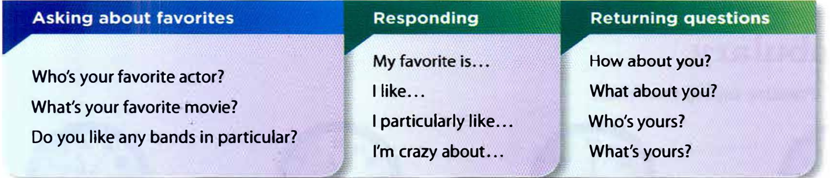

-Take turns asking about favorites, responding, and returning questions.
Use the words from the Vocabulary section.
-Peer-practice and peer-correction.
2.4 Pronunciation Contrastive stress in returning questions
-Listen and notice the stress in the returning questions.
l. I'm fne. How about you?
2. I like it. What about you?
3. pop is my fvorite. What's yous?
4. Rihanna is my fvorite. Who's yours?
-Practice these conversations and pay attention to contrastive stress.
A: Who's your fvorite actress?
B: I love Natalie Portman. How about you?

B: Do you like to watch T shows?
A: Yes, my fvorite show is 30 Rock.
What's yours?
-Correct and give feedback.
2.5 Speak with confidence
-Do the group work activity and ask your classmates about their favorites.
Write down their answers.
sport: ______
restaurant: ______
celebrity: ______
day of the week: ______
-Perform the class activity Share the group favorites for each thing with the class. Then vote on the class favorite.
PART 3 WHAT TIME IS IT?
3.1. Vocabulary
-Listen and practice saying the times.
It's telve o'clock.
It's noon.
It's midnight.
It's twelve fifeen.
It's a quarter after twelve.
It's twelve thirty.
It's half past twelve.
It's twelve fifty-five.
It's five to one
-Draw six clocks with times on a piece of paper. Take turns saying the times.
-Give feedback.
3.2 Conversation
-Listen and answer the question:
Where are Ken and Zack going? What time is the train?
Answer keys:
-to the concert
-six fifteen
3.3 Language Booster
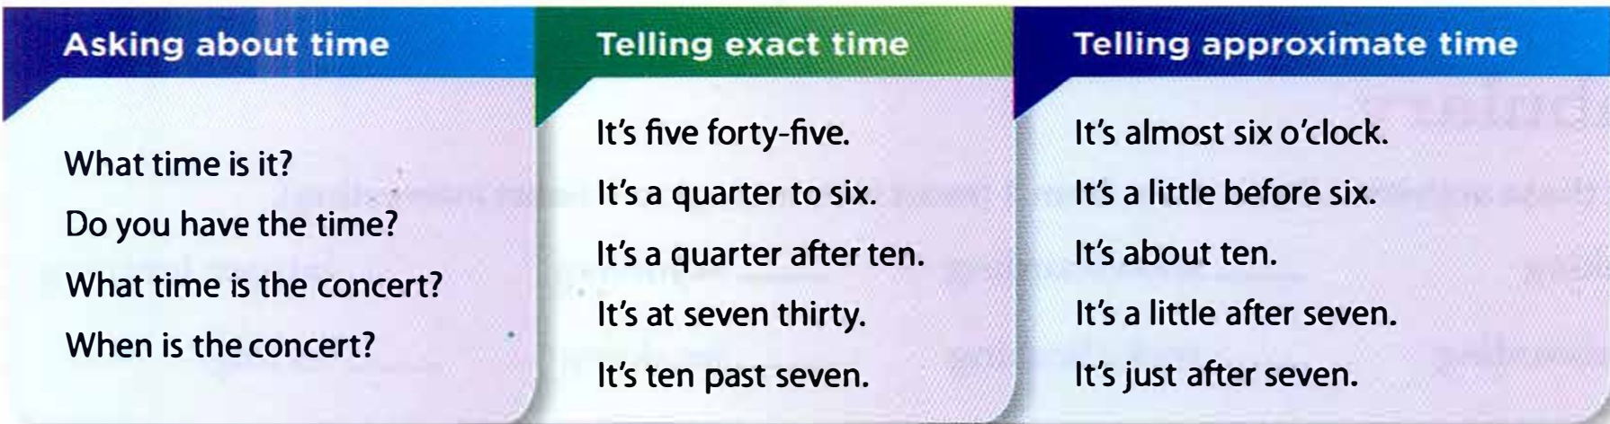
-Notice the different ways we ask about time and tell time.

-Take turns asking about the time and telling the time. Use the ideas below.
your lunch break
your favorite time of the day
a good time to call you
a bad time to call you
-The answer will vary.
-Ask some pairs to present and give feedback.
3.4 Listening
-Listen. People are asking about the times of the events below. Write the times.
A. 1. class: _____ 2. the movie: _____ 3. dinner: _____ 4. the train: _____
-Listen again. Are they going to be late? Circle the correct answers.
B. 1. yes / no 2. yes / no 3. yes / no 4. yes / no
Amswer keys
A. 1. 11 o’clock 2. 2.50 3. 8p.m 4. 6.15
B. 1. no 2. yes 3. no 4. no
3.5 Speak with confidence
-Do the pair work activity:
Study Charlie's appointments. Then cover the picture and take turns asking about his appointments. What can you remember?
-Peer-practice and peer-correction
PART 4 WOULD YOU TRY KAYAKING
4.1 Vocabulary
-Explain the new vocabulary: kayaking, snowboarding, skydiving, bungee jumping, skateboarding, rock climbing, jet skiing, surfng
-Rank them from 1 (most interesting) to 8 (least interesting)
4.2 Conversation
-Listen and answer the question:
How does Lori feel about rock climbing? What does Lori want to do?
Answer keys:
-hard
-walk around today
-Practice the conversation in pairs and peer-correction.
4.3 Language Booster
-Notice the diﬀerent ways we ask for opinions and give opinions.
Asking for opinions
What do you think of
How do you feel about kayaking?
Would you try
Do you think kayaking looks fun?
Giving opinions
I think it's fun and exciting.
I think it's fun, but dangerous.
I don't think it's very safe.
It looks exciting.
It sounds/seems dangerous to me
-Take turns asking for and giving opinions on the sports below.
boxing golf soccer baseball wrestling
-Ask some pairs to speak up and give feedback.
4.4 Pronunciation Stress in compound nouns
-Listen and practice. Notice how the frst noun receives more stress in compound nouns.
1. skateboarding 2. jet skiing 3. rock climbing 4. bungee jumping
-Listen and underline the stress in the words below.
1. snowboarding 2. skydiving 3. river rafting 4. mountain biking
-Take turns asking for and giving opinions on the activities in parts A and B.
Pay attention to stress in compound nouns.
-Give feedback
4.5 Speak with confidence
- Write two examples of activities or sports below.
individual activities:
group activities:
wacrivities:
adventure activities:
-The answer will vary.
- Do the group work activity :
Ask your classmates what they think of the activities you wrote in part A.
-Invite some groups to present in class and give feedback.

